How does SEO work?
Search engines such as Google and Bing use bots to crawl pages on the web, going from site to site, collecting information about those pages and putting them in an index. Think of the index like a giant library where a librarian can pull up a book (or a web page) to help you find exactly what you’re looking for at the time.

How does SEO work?
Search engines such as Google and Bing use bots to crawl pages on the web, going from site to site, collecting information about those pages and putting them in an index. Think of the index like a giant library where a librarian can pull up a book (or a web page) to help you find exactly what you’re looking for at the time.

Next, algorithms analyse pages in the index, taking into account hundreds of ranking factors or signals, to determine the order pages should appear in the search results for a given query. In our library analogy, the librarian has read every single book in the library and can tell you exactly which one will have the answers to your questions.

Our SEO success factors can be considered proxies for aspects of the user experience. It’s how search bots estimate exactly how well a website or web page can give the searcher what they’re searching for.

Unlike paid search ads, you can’t pay search engines to get higher organic search rankings, which means SEO experts have to put in the work. That’s where we come in.

Our Periodic Table of SEO Factors organizes the factors into six main categories and weights each based on its overall importance to SEO. For example, content quality and keyword research are key factors of content optimization, and crawlability and speed are important site architecture factors.

The newly updated SEO Periodic Table also includes a list of Toxins that detract from SEO best practices. These are shortcuts or tricks that may have been sufficient to guarantee a high ranking back in the day when the engines’ methods were much less sophisticated. And, they might even work for a short time now — at least until you’re caught.

We’ve also got a brand new Niches section that deep-dives into the SEO success factors behind three key niches: Local SEO, News/Publishing, and Ecommerce SEO. While our overall SEO Periodic Table will help you with the best practices, knowing the nuances of SEO for each of these Niches can help you succeed in search results for your small business, recipe blog, and/or online

The search algorithms are designed to surface relevant, authoritative pages and provide users with an efficient search experience. Optimizing your site and content with these factors in mind can help your pages rank higher in the search results

Why is SEO important for marketing?

SEO is a fundamental part of digital marketing because people conduct trillions of searches every year, often with commercial intent to find information about products and services. Search is often the primary source of digital traffic for brands and complements other marketing channels. Greater visibility and ranking higher in search results than your competition can have a material impact on your bottom line.
However, the search results have been evolving over the past few years to give users more direct answers and information that is more likely to keep users on the results page instead of driving them to other websites.

Also note, features like rich results and Knowledge Panels in the search results can increase visibility and provide users more information about your company directly in the results.

In sum, SEO is the foundation of a holistic marketing ecosystem. When you understand what your website users want, you can then implement that knowledge across your campaigns (paid and organic), across your website, across your social media properties, and more.

How can I learn SEO?
Hint: Stay tuned for our updated 2021 SEO Periodic Table launching at SMX Advanced on June 15th!
For a helpful dive into SEO, our Periodic Table Of SEO Factors will introduce you to all the key concepts you need to know, including the elements for successful on-page and off-page SEO, plus the “Toxins” or tactics that can hurt your rankings.

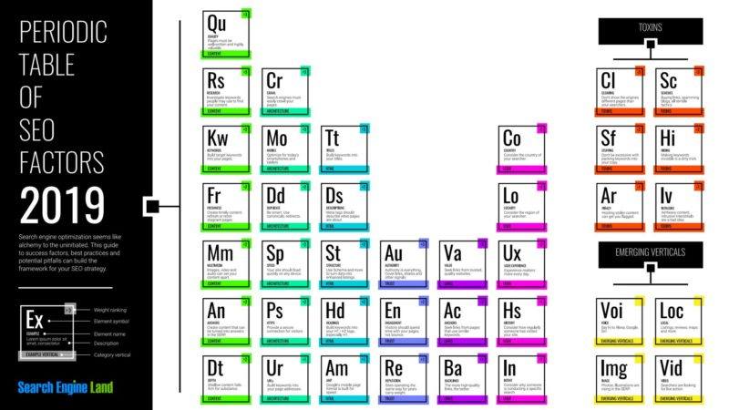
The table and accompanying report also look at three niches of search:
The table and accompanying report also look at three niches of search:
- Local SEO
- Publishing/News SEO
- Ecommerce SEO
The Periodic Table of SE O Factors serves as the foundation of this Guide to SEO. Together, these resources will help you learn about SEO and inform your strategy for success.

Search Engine Land’s Guide To SEO
As a companion to our Periodic Table of SEO Factors, Search Engine Land’s Guide To SEO walks you through the fundamentals of optimizing for search so you can develop a solid strategy to drive organic traffic to yo
In the guide below, we explain these factors in more depth, and highlight tactical tips from experts on search engine optimization that will help your website get more visitors from organic search.

